Niall Smith

PS2

--Collaborated with Ricky Colon.

Written Questions:

1) Based on the images, it displays sensitivity to orientation because frames 3 and 4 have thinner lines compared to 1 and 6.

2) Each cluster would get one half of both circles.

3) When using Hough transforms the graph cut grouping algorithm would be appropriate to recover the model parameter hypotheses because it has a feature extraction technique used for image analysis. Here an imperfect instance of the objects of a certain class of shapes is extracted by a voting procedure which uses parameter space from which candidates with objects are obtained as local maxima so called accumulator space.

4)

Compute the connected components of a binary image.  
B is the binary image.  
LB is a label connected component of an image.  
Pass the B, LB as arguments to the procedure to find and union the blobs based on similarity.  
Initialize the structure.  
Assign the initial labels to each row L of the image.  
Initialize all labels on L to zero.  
Process line L up to maximum column.  
If pixel of binary image is equal to 1 then get the prior neighbors.  
If prior neighbor is empty then assign the label value.  
Increase the label value.  
If prior neighbor is not empty then get the minimum value of the label.  
Label it into the image.  
Call the method to group the similar blobs.

Programming Portion 1: Kmeans

d) Given the image of Jupiter, these are the two histograms, the one on the left being before k=7 equally spaced bins and the one on the right using k=7 cluster center memberships.

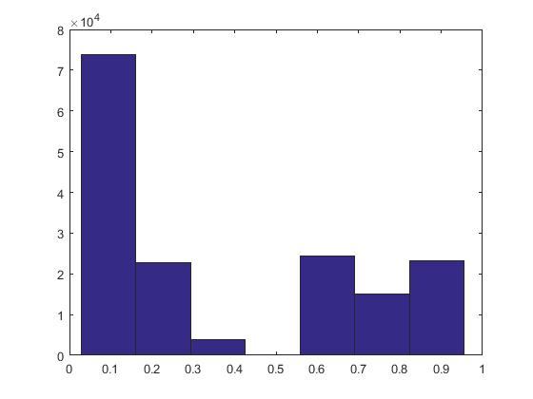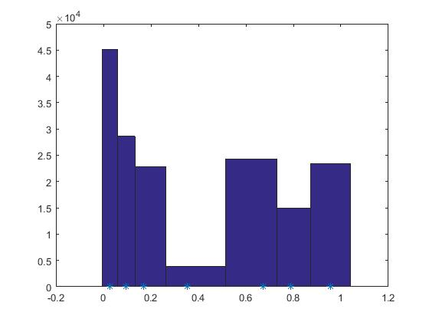

e) Calculated Errors:

k = 5 RGB quantized: 464770734  
k = 5 HSV quantized: 70716903  
k = 25 RGB quantized: 134212474  
k = 25 HSV quantized: 4515641

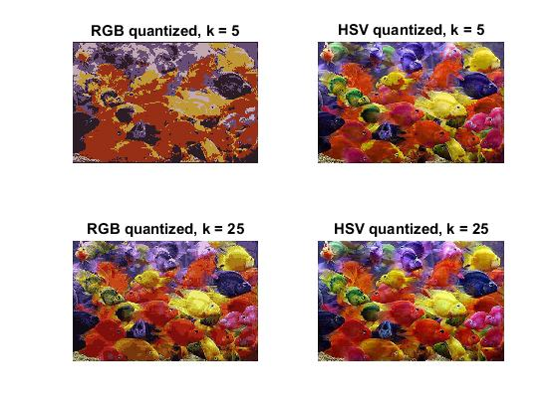

f) The histograms are different in that one shows a k that is for equally spaced bins and is uniform, while the other uses the cluster centers for the range. With larger values of k we see more colors in the RGB image. We see more colors in the HSV image than the RGB image because k-means was only run on the hues of the HSV image and the saturation and brightness of pixels are not clustered and vary. There are different results across each run of k-means with the same k because the Matlab implementation selects the initials centers randomly and this causes different outcomes.

Programming Portion 2: Hough Transform

a) I convert the image to grayscale and then binary. I create a discrete vote space. Where there are ones in the binary image, I increment the votes in all the locations of the vote space that are radius distance from that binary pixel. If usegradient is set to zero, I do not use the gradient for voting, and if it set to one, I do. The areas of the vote space that have the most votes become the centers for which I generate the circles.

b)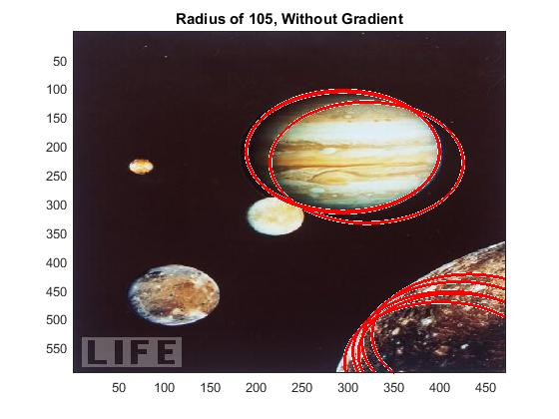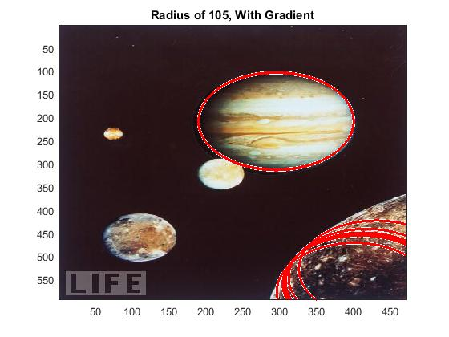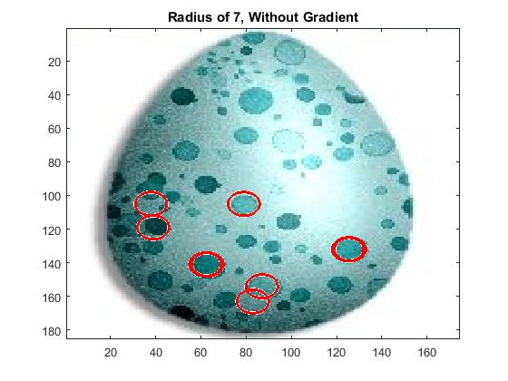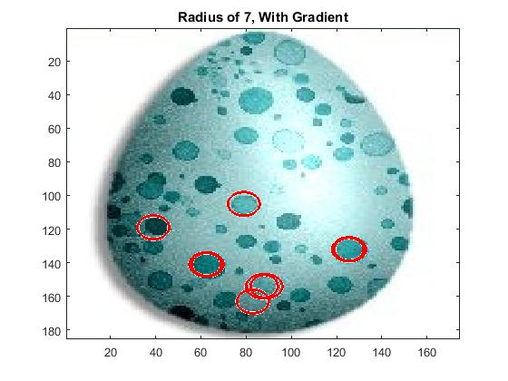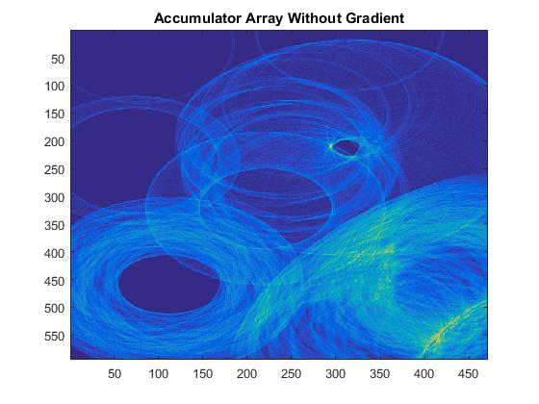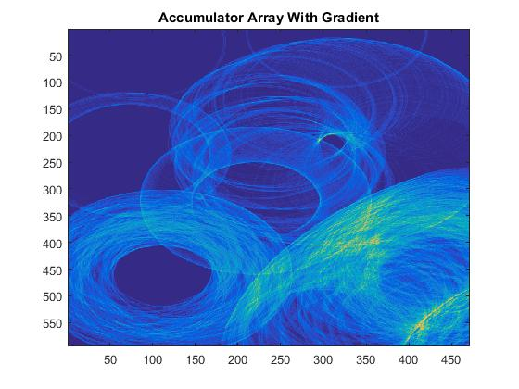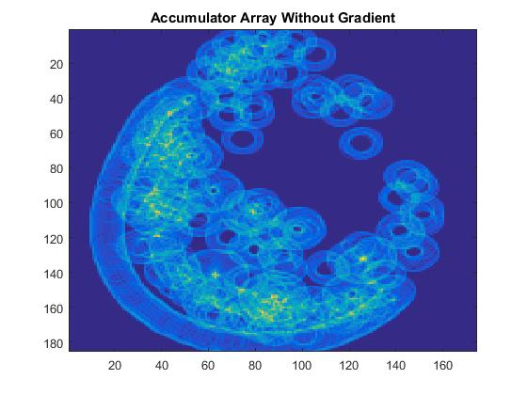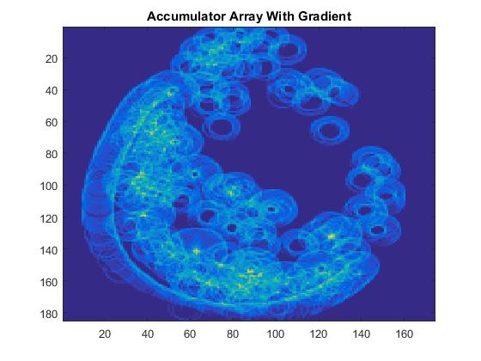

c)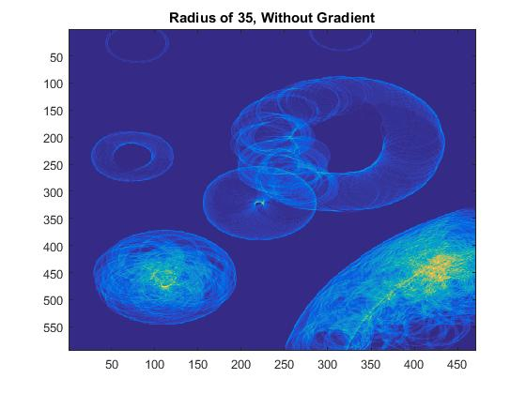

Here is the accumulator array for the Jupiter image using a radius of 35 and without using the gradient. For each 1 that was in the binary image, a vote was cast at all pixels at radius distance. The areas that have the most yellowish colors are those with the most votes cast. These areas would be selected as ideal locations for the centers of the circles that would be detected in the image.

e) This image shows the effect of using an accumulator array that is half the size with a radius of 100 and no use of gradient.

